

Stamford Park Trust

Fairfield High School for Girls

Uniform Policy

April 2025

Policy Title: | Uniform Policy
Document Reference: | SPT/POL/000111/FHS
This policy applies to: | All pupils, parents and staff
Owner/Author: | Head of School
Establishment Level: | School
Approving Body: | Local Governing Body
Review Cycle: | Annual
Date approved: | April 2025
Date of Last Review (this should be the date on the cover): | July 2024
Summary of Changes: | New policy
Date of Next Review: | April 2026
Related Documents/ Policies: | Policy for Outstanding Conduct and Behaviour
Legal Framework/Statutory Guidance: | DfE non-statutory guidance on school uniforms, https://www.gov.uk/government/publications/school-uniform/school-uniforms  DfE statutory guidance on cost of school uniforms, https://www.gov.uk/government/publications/cost-of-school-uniforms/cost-of-school-uniforms

Contents

1 Introduction 5
2 Aims and Objectives 5
3 Roles and responsibilities 5
3.1 The Local Governing Body 5
3.2 Head of School and Senior Leadership Team 5
3.3 Staff 5
3.4 Parents/Carers 6
3.5 Pupils 6
4 Uniform Expectations 6
4.2 Official uniform stockists 8
5 Guidelines 9
6 Discipline 9
7 Help with Cost / Pre-loved Uniform Supplies 9
8 Lost Property 10

Introduction

At Fairfield High School for Girls we have extremely high expectations of our pupils in all aspects of behaviour. These expectations extend to our high standards around uniform. Wearing uniform is an outward sign that pupils are members of the Fairfield school community. Our pupils must look smart at all times both in and around the school grounds and also when in the community, recognising that they are our ambassadors for our school. Pupils must wear school uniform when attending school, or when participating in a school-organised event outside normal school hours, unless exempted from doing so by the Head of School on designated days. We provide a complete list of the items needed for school uniform in this uniform policy and on our website. Effective teaching and learning require organisation and high expectations and standards, and this starts with a smart and tidy appearance which helps to instill discipline and pride in pupils’ appearance and reduces the risk of distraction in lessons.

Aims and Objectives
Our policy is based on the notion that a school uniform;
- promotes a sense of identity and pride for pupils attending the school;
- engenders a feeling of community and belonging;
- is practical and smart;
- is not distracting in class (as fashion clothes might be);
- makes pupils feel equal to their peers in terms of appearance;
- is regarded as suitable, and good value for money by most parents;
- has been designed with health and safety in mind

Roles and responsibilities

The Local Governing Body
- Monitors and reviews the school uniform policy.
- Seeks the views of parents to ensure they agree with and support the policy.
- Requires the Head of School to report to the Governing body on the implementation of the policy.

Head of School and Senior Leadership Team
- To implement and monitor the policy on a day-to-day basis.
- Have overall responsibility for ensuring standards are maintained.
- Are responsible, along with the relevant Head of Year/Pastoral Support Workers and the wider staff team, for any disciplinary measures required for failing to follow the uniform rules and will contact parents/carers as required.
- Consider any requests from parents for special dispensation with regard to uniform

Staff
- Support the Leadership Team in maintaining high standards of uniform dress.
- Are role models in the wearing of appropriate clothing in line with the staff dress code.
- Make discreet and sympathetic enquiries when pupils fail to wear correct school uniform.
- Are aware of pupils whose standard of dress may indicate care issues at home and report concerns to the appropriate persons (see the Policy for Safeguarding and Child Protection).
- Are responsible, along with the relevant Head of Year/Pastoral Support Workers for any disciplinary measures required for failing to follow the uniform rules and will contact parents/carers as required.
- Give positive encouragement to pupils setting good examples of dress.

Parents/Carers
- Support the School Uniform Policy.
- Ensure their pupils are appropriately dressed, wearing correct uniform and are ready to learn.
- Ensure that they keep their child’s school uniform clean and in good condition.

Pupils
- Wear correct school uniform when attending school, representing the school, or when participating in a school-organised event outside normal school hours.
- Wear their uniform with pride.
- Keep their uniform clean and tidy.
- Remember to bring PE kit on the correct days.

Uniform Expectations

Trousers* | Pin stripe, navy blue/green, school design. This is for all year groups. Trousers must not be shortened/tailored to allow the ankle to be seen.
Skirt* | Pleated pin stripe, navy blue/green, school design.  Skirts are NOT to be rolled at the waist.
Blouse* | Years 7/8/9 - green blouse in a shade and style approved by the Local Governing Body and available from stockists.  Years 10/11 - blue blouse in a shade and style approved by the Local Governing Body and available from stockists.  The blouse should be tucked neatly - front and back into the skirt/trousers at all times. T-shirts must not be visible under blouses.
Jumper or cardigan* | Navy blue, v-neck, plain knit, wool or man-made fibre with the Fairfield school badge.
Tights (compulsory with a skirt) | Plain black or navy, at least 60 denier.  No patterns. Socks must not be worn over the top of tights.
Socks (compulsory with trousers) | Plain white, navy or black (up to the knee).  Socks worn with trousers must have no frills or bows or patterns. Socks must not be worn over tights.
Shoes | Plain black shoes, a sensible style without flashes, logos/stripes or trainer soles. No canvas shoes. No bows, ribbons or large metal clasps. No trainers, sports shoe brands such as Adidas, Nike, Converse, Puma are banned. No boots. Any pupil found to be wearing incorrect footwear in school during the day will be expected to change into a pair of pumps (the school keeps a supply of these).  Boots - may be worn to and from school in bad weather, but must be removed and stored in a school bag or locker during the day.  For examples of the types of footwear that are and are not permissible, please see the example pages below.
Jewellery | One pair of small round silver/gold stud earrings only that are worn in the earlobes. For an example of an appropriate stud, please see below.  No hooped/dangly earrings of any size and no piercings in the tragus part of the ear. No pearl or glitter earrings. No other jewellery, e.g. chains, rings, necklaces, bracelets, nose studs, eyebrow studs, lip studs, any other facial or body piercing or body jewellery.  New piercings cannot be covered or replaced with a retainer, or a plaster, they need to be removed.  A wrist watch may be worn as long as it is not a Smart watch.
Bag | A strong waterproof bag which is large enough to hold an A4 file.
Make-up | Very discreet make up is allowed, fake tan is not permitted.  Fake eyelashes of any type, are not permitted. No coloured contact lenses.  No aerosols are allowed in school, e.g. perspirants, deodorants. If pupils wish to use deodorant whilst in school, it must be a roll-on.
Nails | No nail varnish, acrylic/false nails. No builder gel or other similar product. Nails must be natural.
Hair | Long hair must be tied back during examinations, PE and Science and Technology lessons. Hair should be tied with a black, brown, bottle green, navy, plain hair band/bobble.  Head shaving, unnaturally coloured hair, e.g. stripes or two-tone effects. no decoration other than plain bands/ bobbles. No flower type bobbles or bows, or large scrunchies.  Headscarf – headscarves should be plain dark navy or black, with no tassels/fringes or decoration. The scarf should be tied neatly, so the school crest is visible on the jumper/cardigan and the colour of the blouse can be seen. It must not be loose like a scarf as this poses a health and safety risk.
P.E. | Plain white polo shirt either with or without the school badge. Plain navy-blue or black loose fitting football shorts of mid-thigh length. Navy blue or black active wear/sportswear leggings. Cycling shorts are not allowed. Plain white, navy or black socks. Trainers must be worn, please note, pumps/plimsolls/converse type shoes are not allowed owing to health and safety reasons.  A navy hoodie which is unbranded may also be worn as required.  Where possible, hair must be tied up in a bobble.  Optional - navy hoodie with school badge and navy leggings embroidered with the school initials. Note: Hoodies are not to be worn as general school uniform.  Branding/motifs/symbols must not be evident on items of clothing for PE.
Outdoor wear | All outdoor wear including jackets, scarves, gloves or hoodies must not be worn in the school building.
Summer Uniform | Any change to the uniform, as a result of warmer weather, will be up to the discretion of the Headteacher. At this time jumpers will become optional.  In a case of extreme heat, the Headteacher may grant permission for pupils to wear their PE kit.

Official uniform stockists

M.C.S. STORES | 32 Market Street – Ashton-Under-Lyne – OL6 6ER  Telephone Number – 0161 339 9845 or 0161 445 7740  https://mcsstores.co.uk
PANACHE SCHOOL WEAR | 90 Market Street  Droylsden  M43 6DE  https://panacheschoolwear.co.uk
TOP MARKS SCHOOLWEAR | 82 Old St, Ladysmith Centre, Ashton-under-Lyne OL6 7JR  https://topmarksschoolwear.co.uk (Shop & on-line ordering)
SALLIES SCHOOLWEAR | 39 Manchester Road – Denton – Manchester – M34 3JU  Telephone Number – 0161 336 3305  https://salliesschoolwear.co.uk

Guidelines

It is expected that all pupils wear the school uniform each school day with the appropriate footwear.

Uniform is checked each morning and failure to comply with expectations will result in a sanction. If failure to wear the correct uniform is identified as a persistent issue, parents/carers will be contacted. The pupil will also be provided with uniform to wear. Refusal from the pupil to do this will result in the pupil being placed in Internal Isolation for the remainder of that day.

If a pupil arrives at school without the full correct uniform with communication from parents/carers, the missing item will be provided by the school for them to wear or parents may support with bringing it into school where possible, with the expectation that the issue will be fully resolved the following day. If the school does not have the missing item available, a note will be issued to the pupil for that day only.

Pupils are responsible for taking care of their own school uniform and that borrowed from school.
Pupils who repeatedly come to school without the correct school uniform maybe placed in the Internal Isolation and parents/carers will be asked to attend a meeting in school to resolve the issue.

Discipline

The Headteacher has the legal authority to discipline pupils for not wearing correct school uniform (see www.gov.uk/school-discipline-exclusions). In extreme cases a pupil could be excluded for persistently failing to wear school uniform. It is our intention to explore all avenues, through consultation and discussion with parents/carers, to avoid this sanction being taken. If a pupil arrives not wearing the correct uniform school will endeavour to find the cause and remedy the situation. A letter will be sent home to parents. Should the problem persist, parents/carers may be invited into school to discuss the situation.

Help with Cost / Pre-loved Uniform Supplies

If any parent/carer cannot provide their pupil with school uniform because they cannot afford it, financial help may be available. School uniform may include clothes for PE. The parent/carer should initially talk to the Head of Year or Assistant Head of Year. The school maintains a limited hardship fund which supports families in need, helping to ensure that every child has opportunity to participate fully in school life. This includes helping families who are struggling to meet the costs of uniform, particularly branded items which cannot be purchased from general retailers.
Applications should be made in writing to the Headteacher, who has the final decision about allocation of this fund, made in in consultation with senior and pastoral colleagues. The hardship fund is finite and requests will be processed in the light available resources. Whilst we offer no guarantees that every application will be successful, we encourage those who are in genuine need to consider this as a viable option.

Any unclaimed items of lost property, together with donations of clean, good condition, outgrown or leavers’ uniform items can be made available for families at no cost. We ask that families use these items to minimise waste and protect the environment. Items can be requested discreetly through the ‘admin’ email on our website.

Lost Property

Any unidentified items of school uniform will be placed on the rail in the pastoral Hub. Pupils are encouraged to go to the Hub to reclaim lost property on the understanding that the found item will be clearly named.

PE items:
Permissible
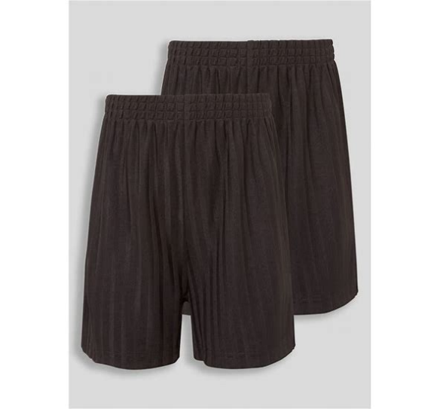
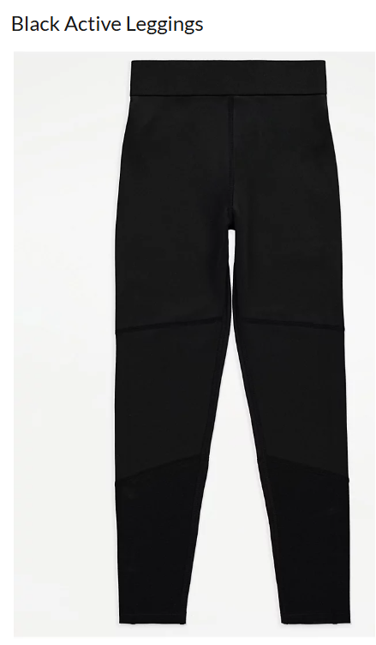

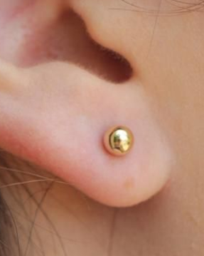

Permissible earing example


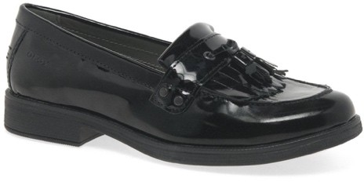
EXAMPLE TYPES OF FOOTWEAR PERMITTED
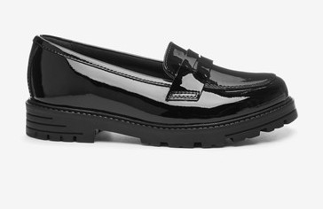
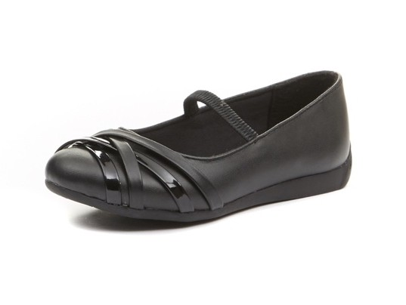
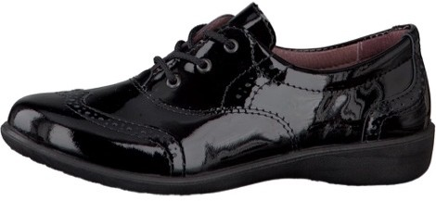
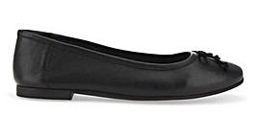
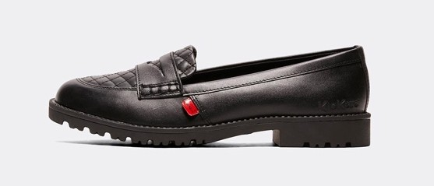
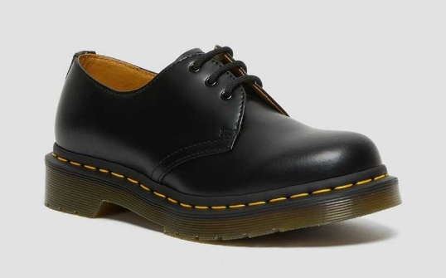
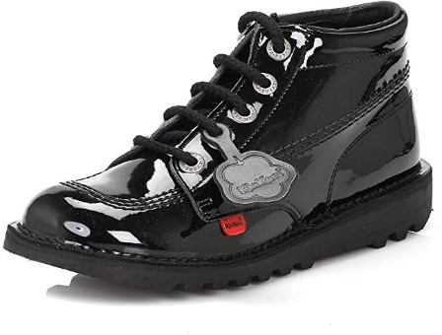

The images above provide examples of the type of footwear which is allowed to be worn. This is not a definitive list and the school leadership team reserves the right to determine appropriate footwear in line with the guidelines set out in this policy.
If you are unsure about a certain type of footwear, please contact the school before purchasing.

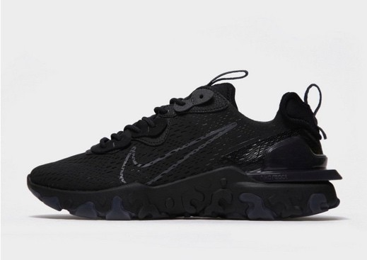
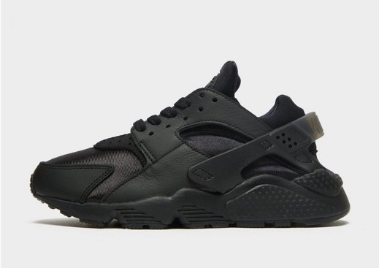
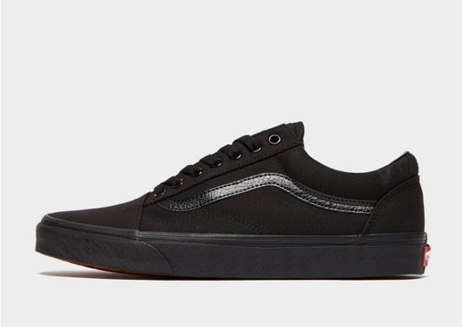
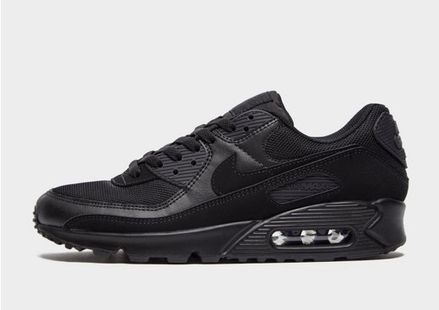
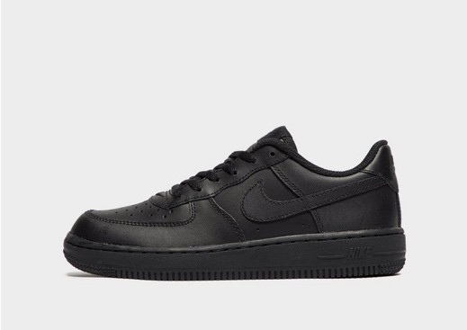
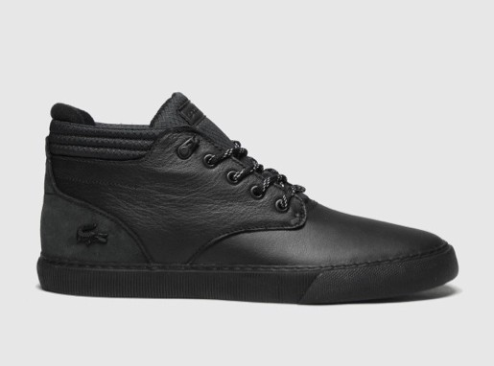
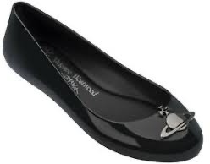
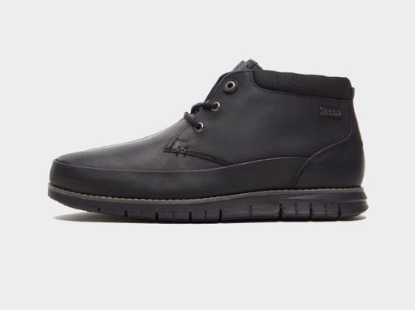
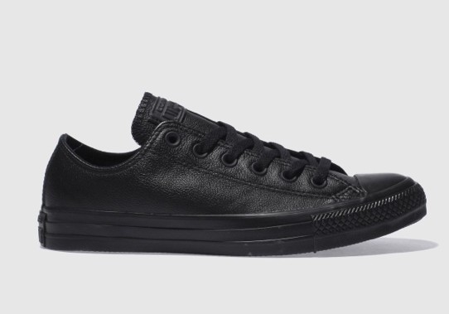
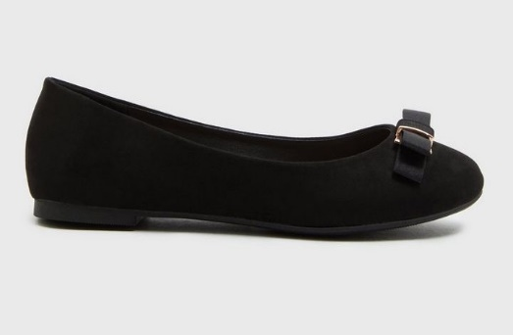
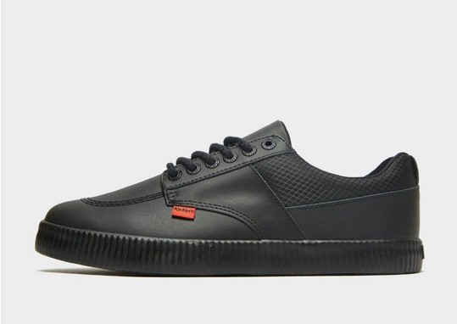
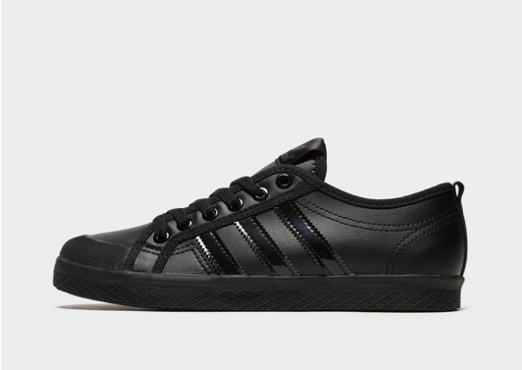
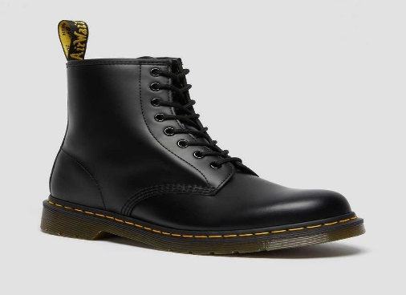

EXAMPLE TYPES OF FOOTWEAR NOT PERMITTED

The images above provide examples of the type of footwear which is not allowed to be worn. This is not a definitive list and the school leadership team reserves the right to determine appropriate footwear in line with the guidelines set out in this policy

If you are unsure about a certain type of footwear, please contact the school before purchasing.
- No trainers
- No canvas or plastic footwear
- No boots or ankle boots
- No large adornments such as buckles or bows
- No different coloured soles or coloured elements

