

DOCUMENT REFERENCE:

THIS POLICY APPLIES TO:All staff and pupils

OWNER/AUTHOR: Deputy Headteacher for Curriculum and Standards

ESTABLISHMENT LEVEL: School

APPROVING BODY: Local Governing Body

REVIEW CYCLE: Annual

DATE APPROVED: October 2026

LAST REVIEWED ON:

NEXT REVIEW DUE BY: October 2027

SUMMARY OF CHANGES:

RELATED DOCUMENTS/POLICIES: See section (vi)

LEGAL FRAMEWORK/STATUTORY GUIDANCE: See related policies in section (vi)

FEEDBACK POLICY
FAIRFIELD HIGH SCHOOL FOR GIRLS
Contents

(i) Rationale 3
(ii) The Fairfield Principles of Feedback 3
(iii) Subject Implementation 5
(iv) Roles and Responsibilities 5
(v) Monitoring and Quality Assurance 6
(vi) Policy Review and Related Documents 6
Appendix 1: Core Expectations for Teachers – Feedback 7
Appendix 2: The Five Rs of Action Feedback 8

(i) Rationale
The purpose of feedback is to help pupils improve their learning and close the gap between their current understanding and the intended curriculum end-points. Effective feedback builds on high-quality teaching and formative assessment, helping pupils recognise what they have understood, identify misconceptions and know what to do next. It should strengthen subject knowledge, develop independence and support pupils to apply their learning with increasing confidence.
Dylan Wiliam emphasises that feedback is effective when pupils use it to move their learning forward. Providing comments or identifying errors is therefore only part of the process: teachers must also plan opportunities for pupils to understand, act upon and apply the guidance they receive. Pupils’ responses and subsequent learning should inform further teaching, explanation and practice.
Informed by the Education Endowment Foundation’s Teacher Feedback to Improve Pupil Learning guidance report (2021), this policy prioritises the purpose and impact of feedback over its format or quantity. Feedback may be verbal, written or digital, and delivered individually, to groups or to the whole class. Teachers should select approaches that are timely, accessible and appropriate to the subject and pupils’ needs, while maintaining a proportionate workload. Its effectiveness is judged by how it supports learning, rather than the volume of marking produced.

(ii) The Fairfield Principles of Feedback
(1) High-quality instruction – Effective feedback builds on expert teaching through explanations, modelling and questioning, as described in the Fairfield Expert Teaching Cycle. Teachers use formative assessment and checks for understanding to identify learning gaps before deciding what feedback is needed.
(2) Learning objectives – Pupils should understand the intended learning and what successful work or performance looks like. Teachers revisit learning objectives and success criteria when checking understanding and helping pupils assess their progress.
(3) Focus – Feedback should address specific gaps and misconceptions against the intended learning, success criteria and curriculum end-points. It should provide manageable next steps focused on the task, subject knowledge or strategies for regulating learning. Marks and grades alone do not necessarily explain how to improve.
(4) Written feedback – Written feedback should be purposeful, proportionate and timely enough for pupils to use it. Personalised written feedback is not required for every task. Comments, questions, targets or improvement tasks should be selected for their educational value, taking account of staff workload and opportunity cost.
(5) Verbal feedback – Teachers should use verbal feedback where it best meets the learning need, including individual, group or whole-class feedback and feedback on practical work. There is no required ratio of written to verbal feedback. Teachers are not required to transcribe verbal feedback or use stamps solely to demonstrate that it occurred.
(6) Self- and peer assessment – Teachers should provide opportunities for pupils to assess their own work and, where appropriate, the work of others. Clear criteria, worked examples, exemplars and guided practice should help pupils make accurate judgements. Teachers should check these judgements and address misconceptions.
(7) Responding to feedback – Pupils must have opportunities to apply feedback through corrections, further practice, improved work or a subsequent task. Teachers should check whether the response has addressed the identified gap and provide further explanation, practice or reteaching where needed. Completing an improvement task alone does not establish secure learning. See Appendix 2: The Five Rs of Action Feedback.
(8) Accessibility – Feedback should be accessible to all pupils, including those with SEND, disadvantaged pupils and pupils with EAL. Teachers should adapt its language, format, amount and supporting explanation to identified needs, use manageable next steps and check that pupils understand what to do. Agreed support in EHC Plans and Individual Support Plans should inform these adaptations.
(9) Motivation and praise – Feedback should be respectful, specific and constructive, taking account of pupils’ confidence and readiness to receive it. Praise should recognise successful strategies, effort and improvement where appropriate, including through RISE points and Golden Tickets. Praise complements, but does not replace, guidance on learning.
(10) Subject expertise – Teachers should use professional judgement to select the focus, method and timing of feedback according to the curriculum and pupils’ needs, within agreed subject guidance. Subject arrangements must reflect these principles and support effective, manageable practice.

(iii) Subject Implementation
Faculty and Subject Leaders will document the subject’s approach to feedback in its Curriculum Rationale. This must identify which assessments and types of work should receive written feedback, the expected frequency and timing of marking, and opportunities for pupils to act on feedback, in line with the Fairfield Principles of Feedback. Where exercise books are used, guidance must specify expectations for reviewing and marking their contents, including the work selected for closer attention.
Expectations should be clear, proportionate and manageable, supporting consistency while allowing teachers to respond to identified learning needs. Personalised written feedback is not required on every piece of work. Faculty and Subject Leaders will communicate these expectations to staff and review them through quality assurance, taking account of pupils’ learning and staff workload.
Feedback on home learning should align with the Home Learning Policy and the subject’s agreed marking expectations. Automated marking, self- or peer-assessment and whole-class feedback may be appropriate. A completion check confirms that work has been done but does not necessarily tell pupils how to improve; where a learning gap is identified, pupils should receive appropriate guidance and follow-up.
For handwritten feedback, staff use a colour other than red; pupils use red for corrections and improvements where appropriate. Digital, verbal and practical responses, and agreed accessibility adjustments, remain valid.
(iv) Roles and Responsibilities
Senior leaders – Oversee implementation, support professional development and evaluate the effectiveness and workload implications of feedback across the school.
Faculty and Subject Leaders – Establish and communicate subject guidance, support staff through modelling and shared practice, and evaluate how effectively feedback improves pupils’ learning.
Teachers – Identify learning gaps, provide appropriate feedback, enable pupils to act on it and check its impact. Seek advice from subject leaders or the SENDCO where further support is needed.
Pupils – Engage with feedback, seek clarification when unsure, apply guidance and use it to improve subsequent work and learning. Staff will support pupils to develop these habits.
(v) Monitoring and Quality Assurance
Senior, Faculty and Subject Leaders will evaluate feedback through our quality assurance processes, drawing on lesson visits, work scrutiny, pupil voice, moderation processes and assessment evidence. Evaluation will consider whether pupils understand and use feedback, whether identified gaps are addressed and whether subsequent learning improves, including for pupils with additional needs.
Leaders will check that agreed subject expectations are implemented consistently and evaluate their impact on learning. The effectiveness of feedback will not be inferred from the quantity of marking, coloured pen or records of verbal feedback. Leaders will use findings to refine subject approaches and professional development, considering staff workload and avoiding additional documentation solely for monitoring.

(vi) Policy Review and Related Documents
The Deputy Headteacher for Curriculum and Standards will review this policy annually, in consultation with relevant leaders and informed by implementation evidence and staff and pupil feedback. Earlier review will take place where significant changes are required. Approval will follow the Trust’s scheme of delegation.
This policy should be read alongside the Curriculum Policy, Home Learning Policy, Learning and Teaching Policy, Assessment Policy, SEND Policy and the Fairfield Expert Teaching Cycle.
Research guidance: Education Endowment Foundation, Teacher Feedback to Improve Pupil Learning (2021), and the Feedback strand of the Teaching and Learning Toolkit. These are research resources, not statutory guidance.
EEF guidance: https://educationendowmentfoundation.org.uk/education-evidence/guidance-reports/feedback
EEF Toolkit: https://educationendowmentfoundation.org.uk/education-evidence/teaching-learning-toolkit/feedback

Appendix 1: Core Expectations for Teachers - Feedback
- Identify learning needs – Use questioning, assessment and pupils’ work to identify gaps against the intended learning and success criteria.

- Give precise guidance – Provide manageable next steps that address misconceptions and help pupils improve their knowledge, understanding or performance.

- Follow subject expectations and choose an appropriate approach – Follow agreed requirements for written feedback, marking frequency and exercise-book review. Select verbal, written, whole-class or digital feedback according to the learning need. Personalised written feedback is not required for every task.

- Make feedback accessible – Adapt explanations and support to pupils’ needs and check that they understand what to do next.

- Enable pupils to act – Provide opportunities to apply feedback through corrections, further practice, improved work or a subsequent task.

- Check the impact – Review pupils’ responses and subsequent learning, providing further explanation, practice or reteaching where gaps remain.

- Support confidence and independence – Give respectful, constructive feedback and recognise successful strategies, effort and improvement where appropriate.

- Use agreed written conventions – For handwritten feedback, staff use a colour other than red; pupils use red for corrections and improvements where appropriate. Digital, verbal and practical responses, and agreed accessibility adjustments, remain valid.
Appendix 2 – The Five Rs of Action Feedback
Following Dylan Wiliam’s principle that feedback should move learning forward, teachers should provide actionable guidance and opportunities for pupils to use it. Tom Sherrington’s Five Rs of Action Feedback offer practical ways to plan these responses:

Redraft or Re-do: improve existing work.
Rehearse or Repeat: develop fluency through focused practice.
Revisit and Respond: answer further questions addressing learning needs.
Re-learn and Re-test: strengthen knowledge through retrieval.
Research and Record: deepen understanding through directed enquiry.
Teachers should select an appropriate action, give specific instructions and check that pupils’ responses demonstrate improved understanding or performance.
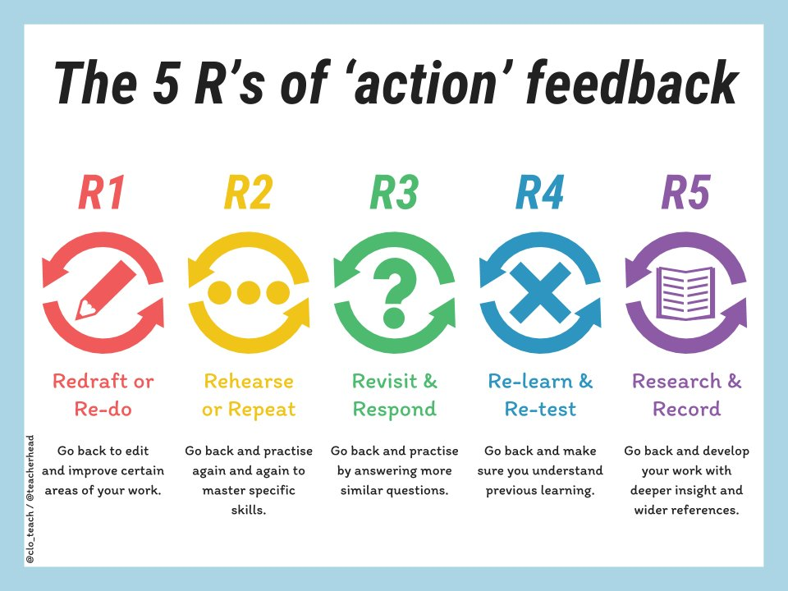
Source: Tom Sherrington (2017), Five Ways of Giving Effective Feedback as Actions.
https://teacherhead.com/2017/12/18/fiveways-of-giving-effective-feedback-as-actions/

